**OS - Practical - 1**

**Name: Rishabh Jain**

**Branch & Sem: CSE - IV**

**Sec: A**

**Roll no.:54**

**Aim:** To study and execute basic Linux System Commands and write shell scripts to display the system particulars (processor, processes and memory).

**QUE 1**) Execution of all the steps given in below snippet. (touch, ls, cd, mkdir , chmod –R 777how to create and handle and execute script.

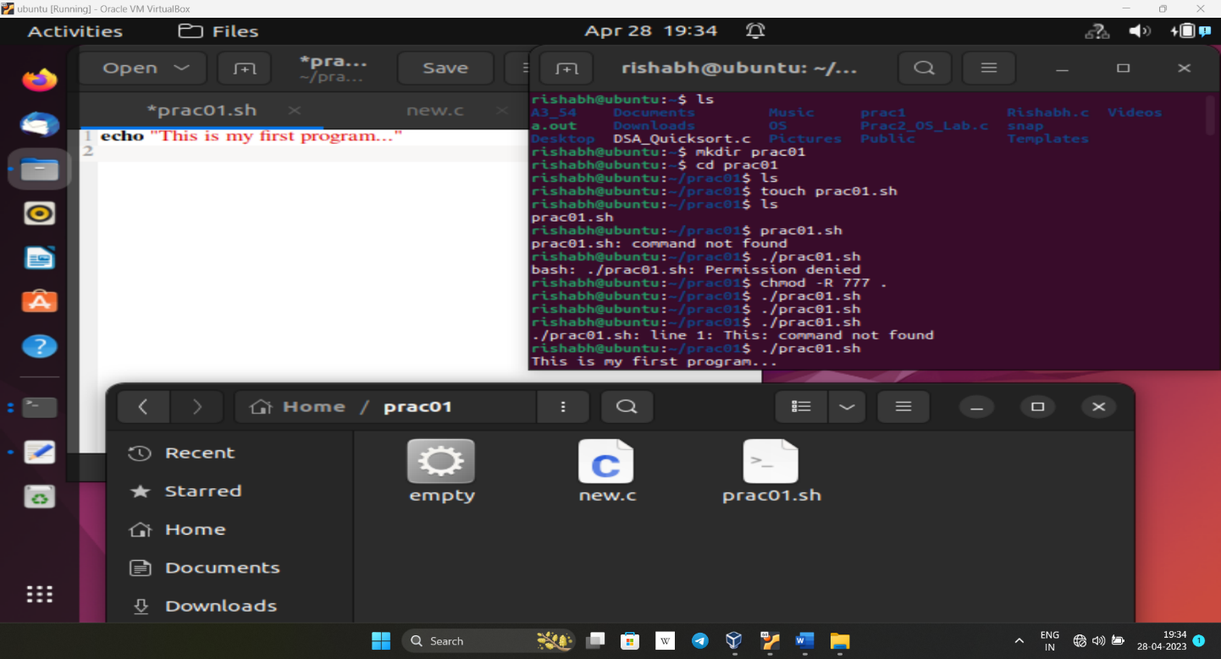

**Code**:

* Ls
* Mkdir prac01
* Cd prac01
* Ls
* Touch prac01.sh
* Ls
* ./prac01.sh
* chmod -R 777 .
* ./prac01.sh

**QUE 2**) Create a shell script to perform the following tasks.

(a) Find the number of processors your machine has.

(b) How many cores does your machine have?

(c) What is the frequency of each processor?

(d) How much physical memory does your system have?

(e) How much of this memory is free?

(f) What is total number of number of forks since the boot in the system?

(g) How many context switches has the system performed since bootup?

**Code**:

* Gedit prac01.sh
* (write the code into the file prac01.sh)
* ./prac01.sh
* Chmod -R 777 .
* ./prac01.sh
* Lscpu
* Cat /proc/meminfo
* Cat /proc/cpuinfo

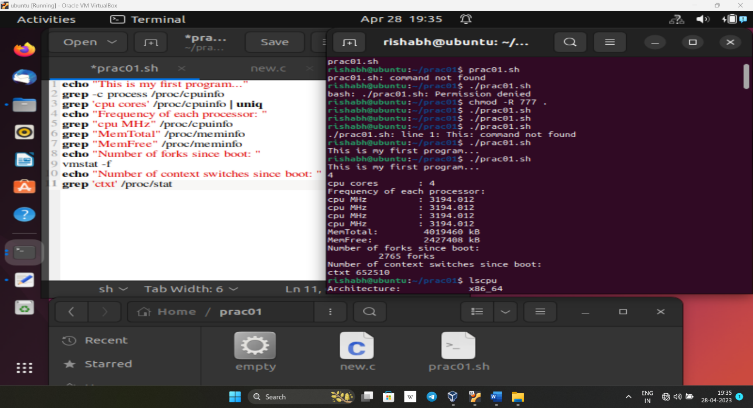

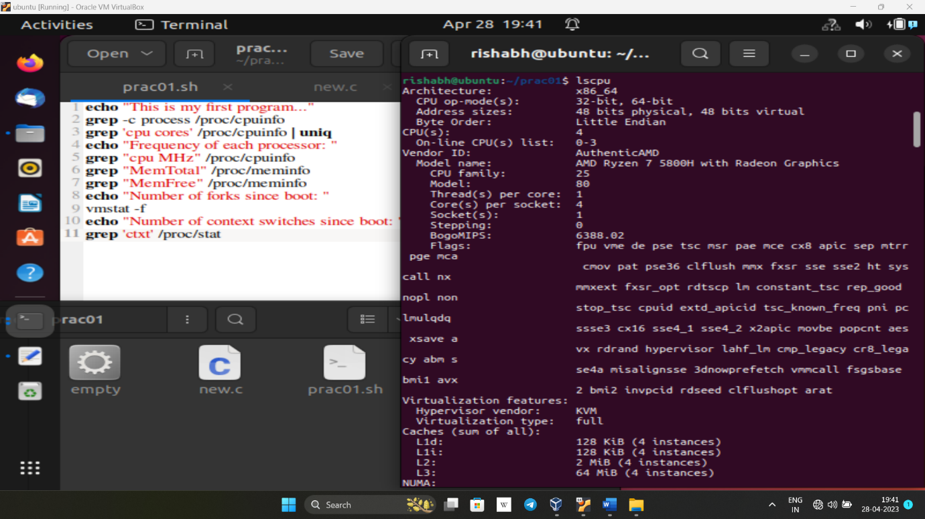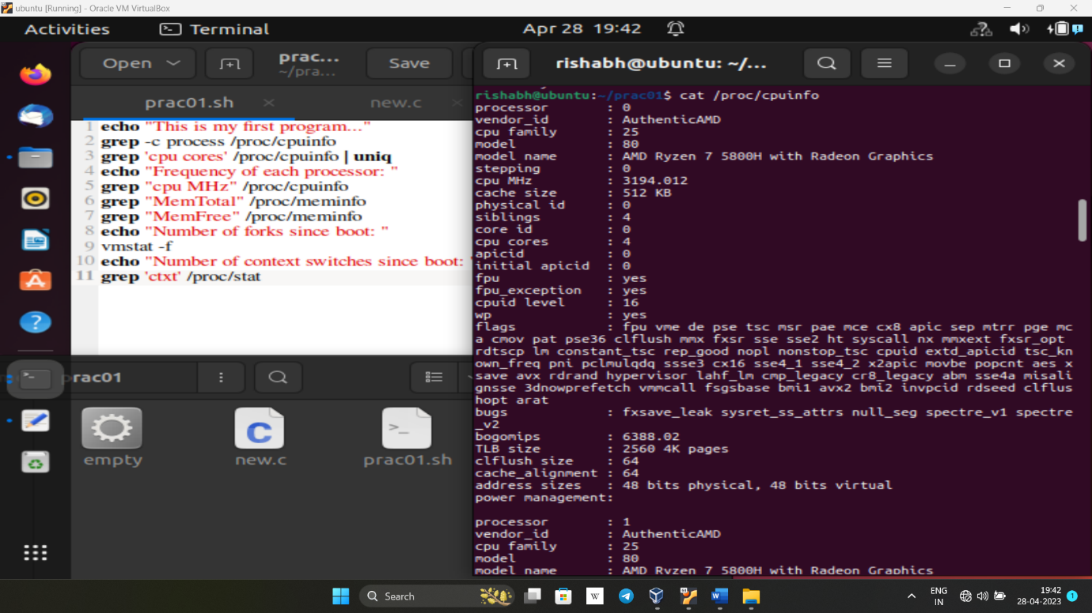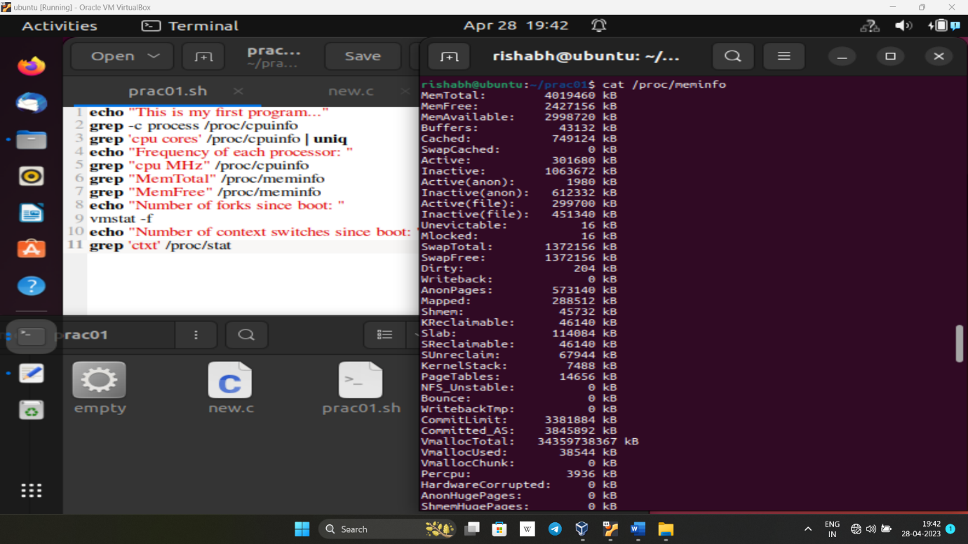

**QUE 3**) Run strace along with the binary program of empty.c given in subdirectory strace .

What do you think the output of strace indicates in this case? How many different system

call functions do you see?Next, use strace along with another binary program of hello.c (which is in the samedirectory).Compare that is observe the two strace outputs

a. Which part of the strace output is common, and which part has to do with the

specific program?

b. Observe the list of all unique system calls along with input and output parameters and study those system call ?

**Code :**

* Gedit new.c
* Gcc -o empty new.c
* Strace ./empty
* Gedit hello.c
* Gcc -o hello hello.c
* Strace ./hello
* Strace -o hello-trace1 ./hello
* Strace -o hello-trace2 ./hello
* Diff hello-trace1 hello-trace2

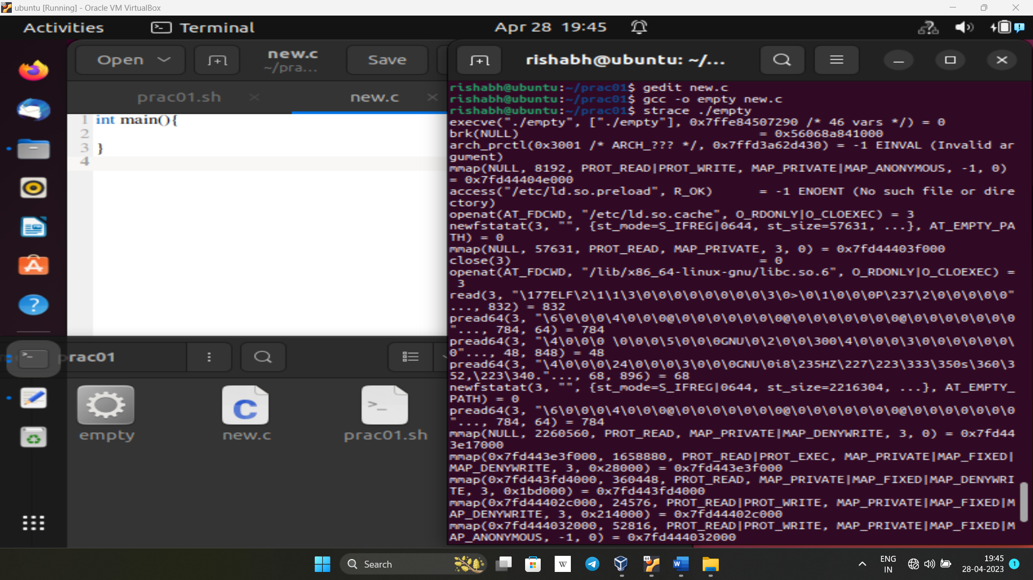

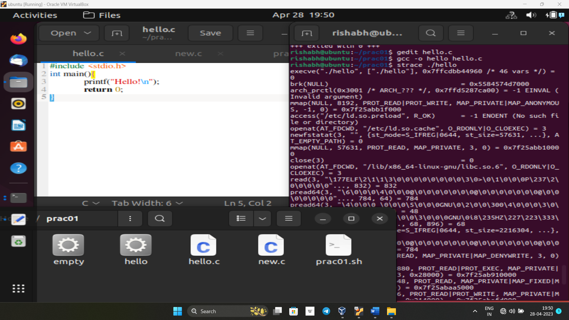

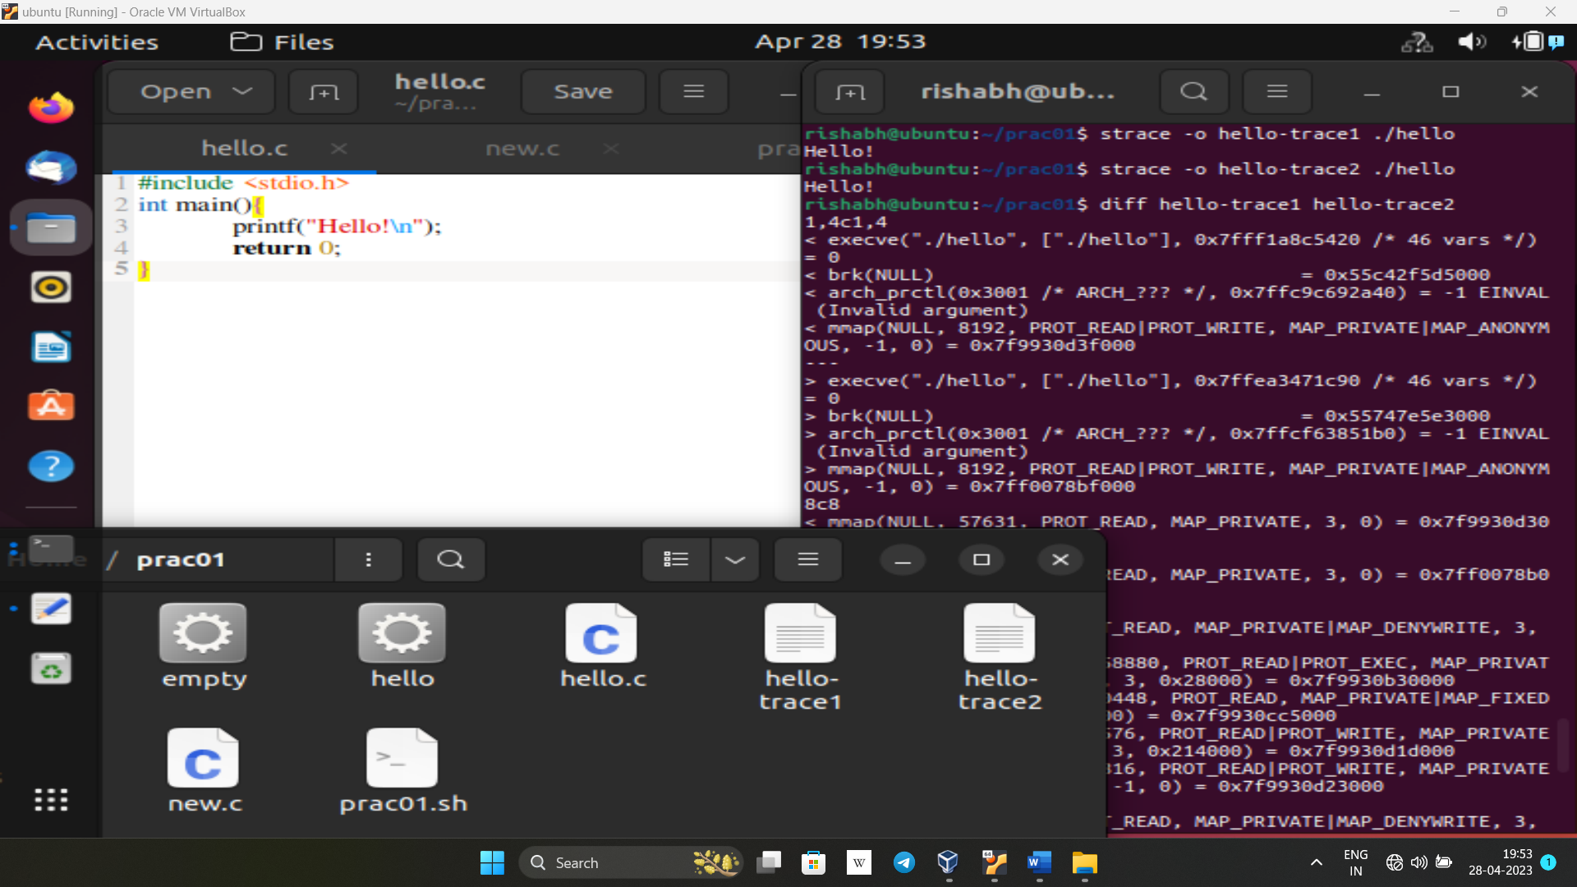

**QUE 4**) Execute following commands:

1. clear

2. cal

3. who&amp;whoami

4. date

5. mkdir

6. rm

7. cat

8. cd

9. cp

10. grep

11. ls (execute all options)

12. mv

13. rm

14. rmdir

15. echo

16. uptime

17. uname, hostname

18. touch

19. cut

20. Head, tail

21. ps

22. chmod (execute for all permissions, (reference: OS lab manual pdf , pg no. 34)

23. wc

24. chown

25. Man

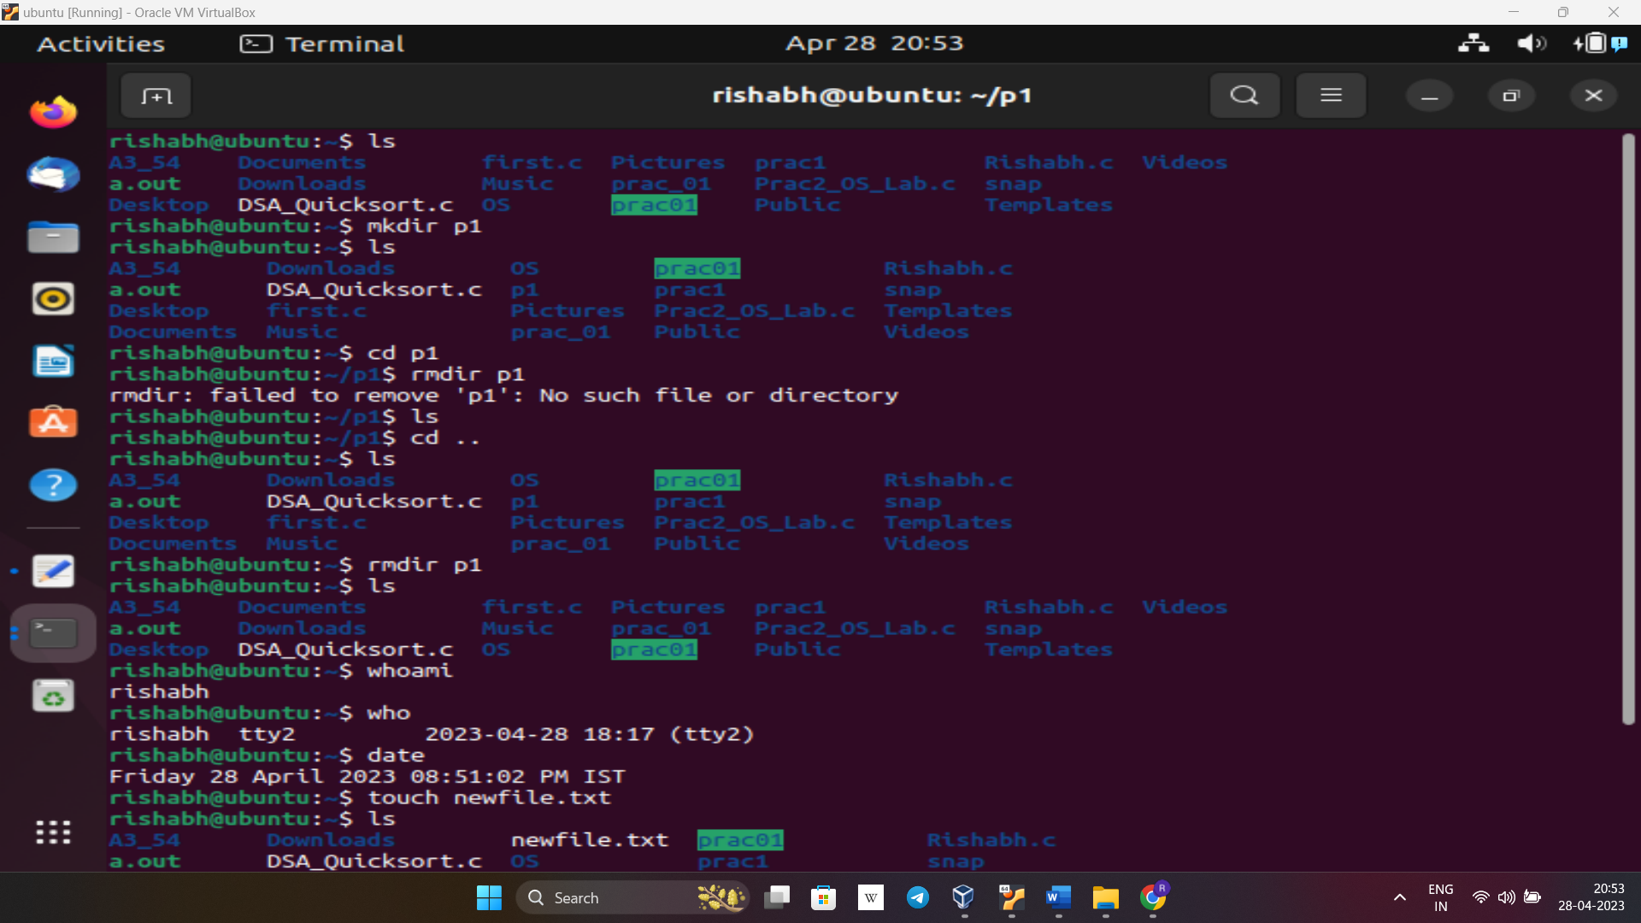

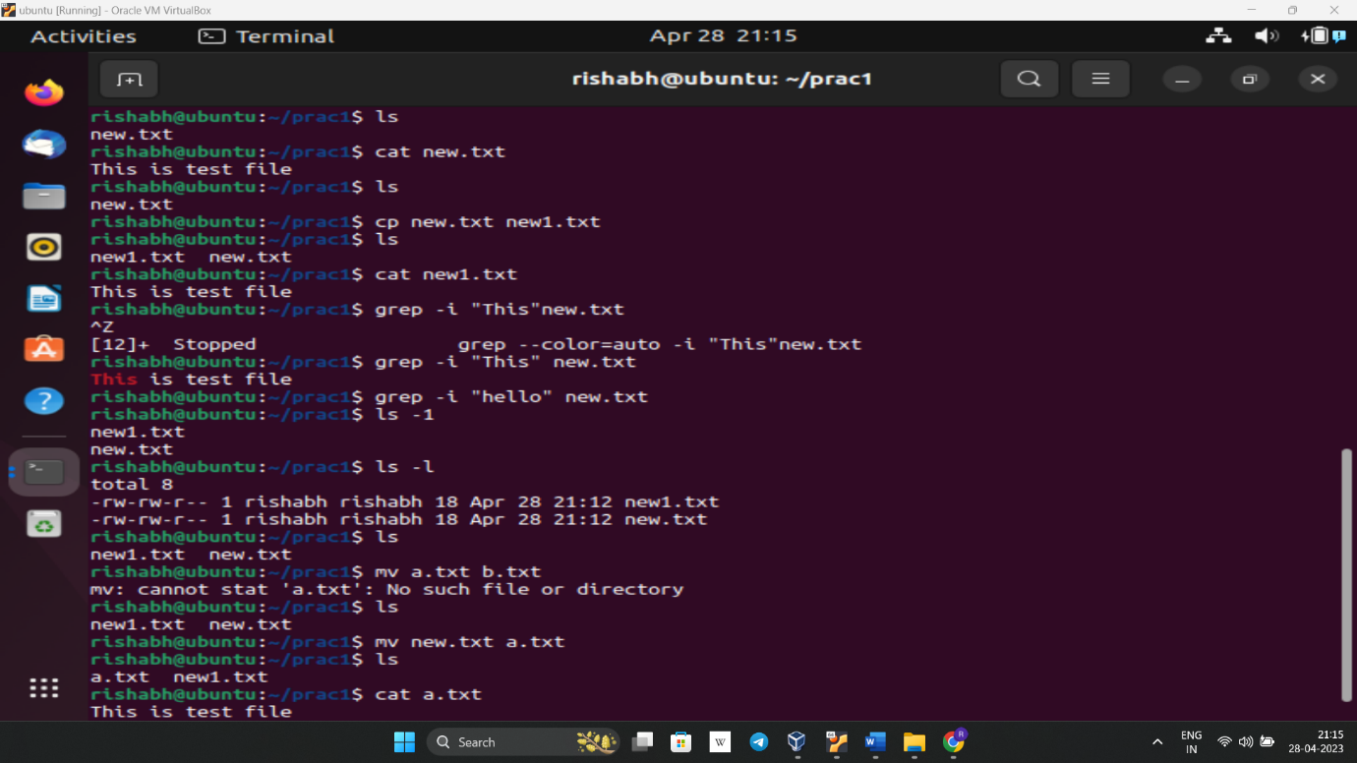

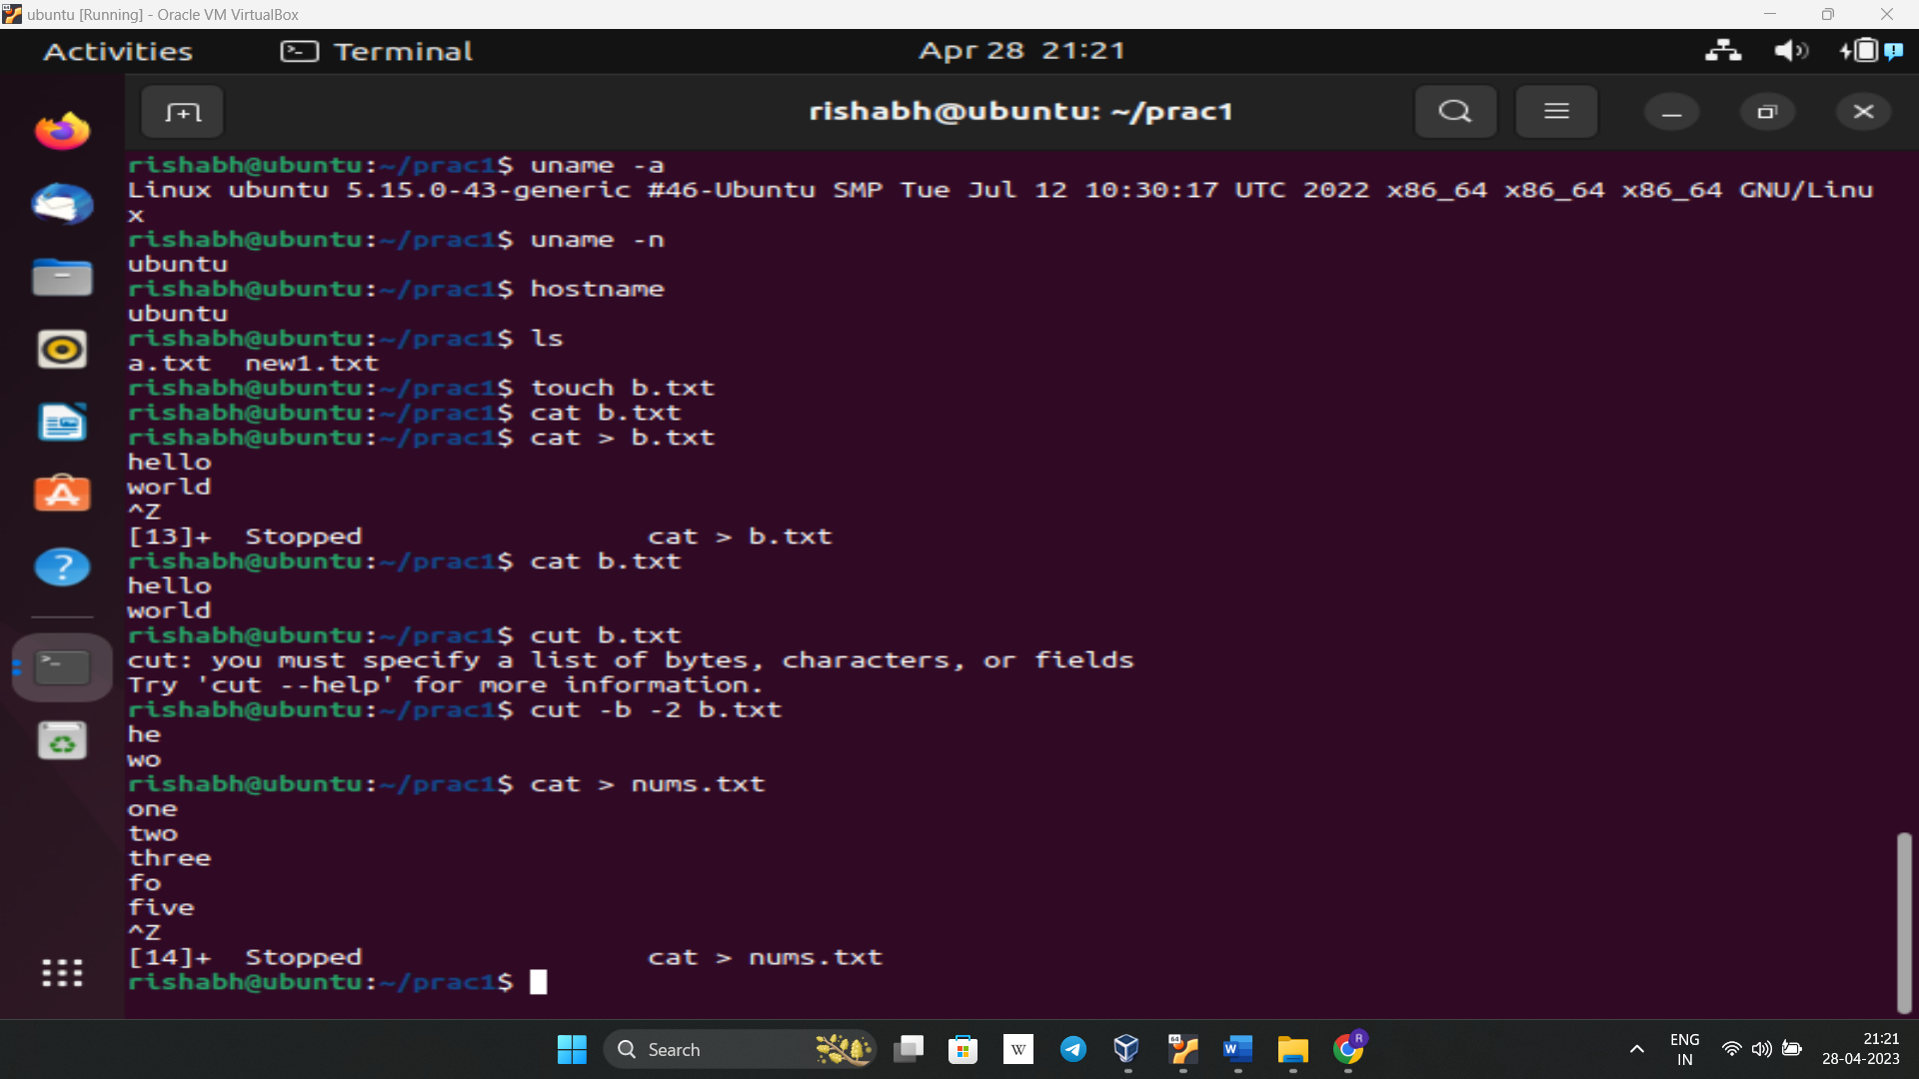

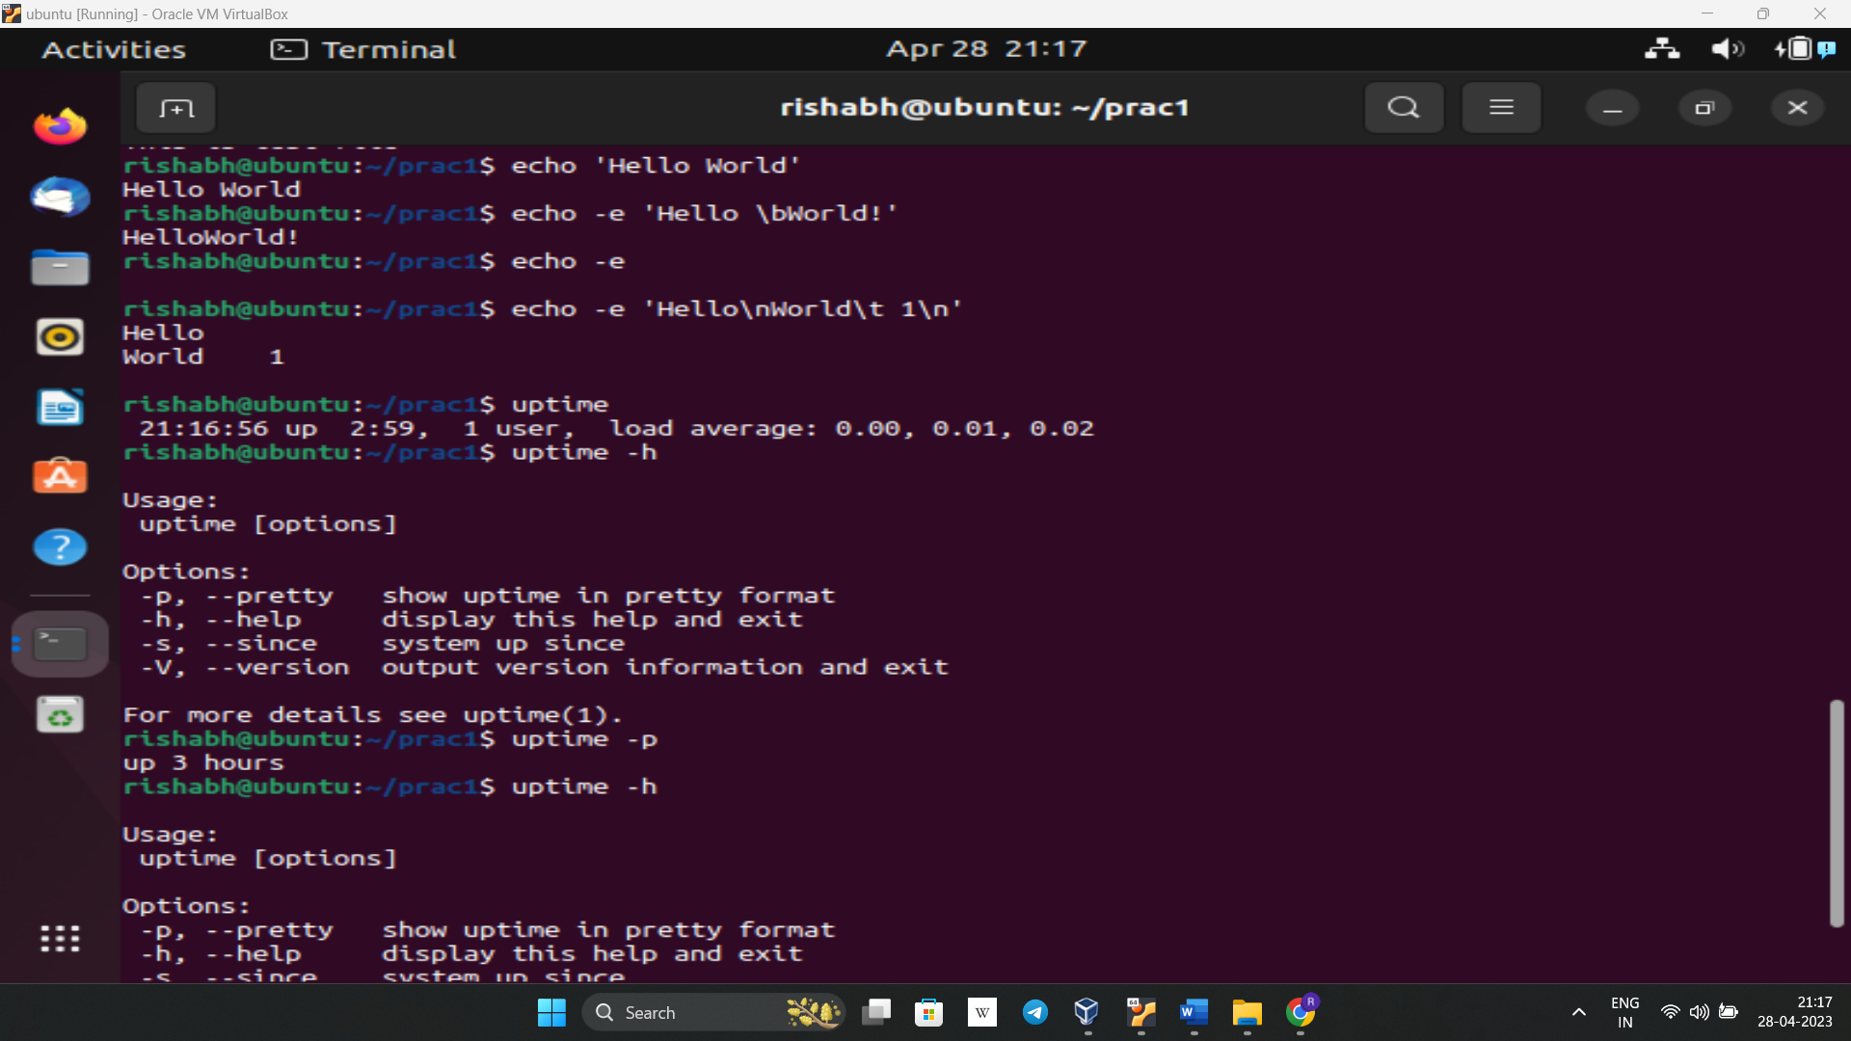

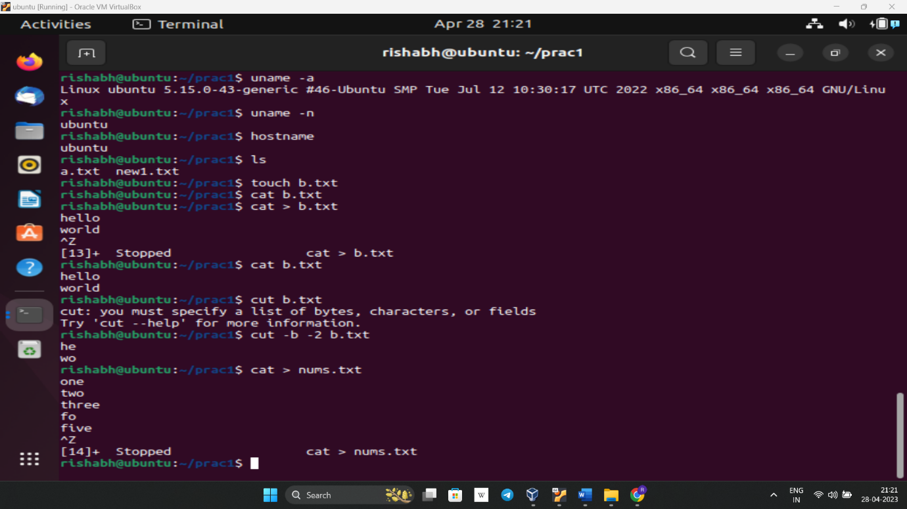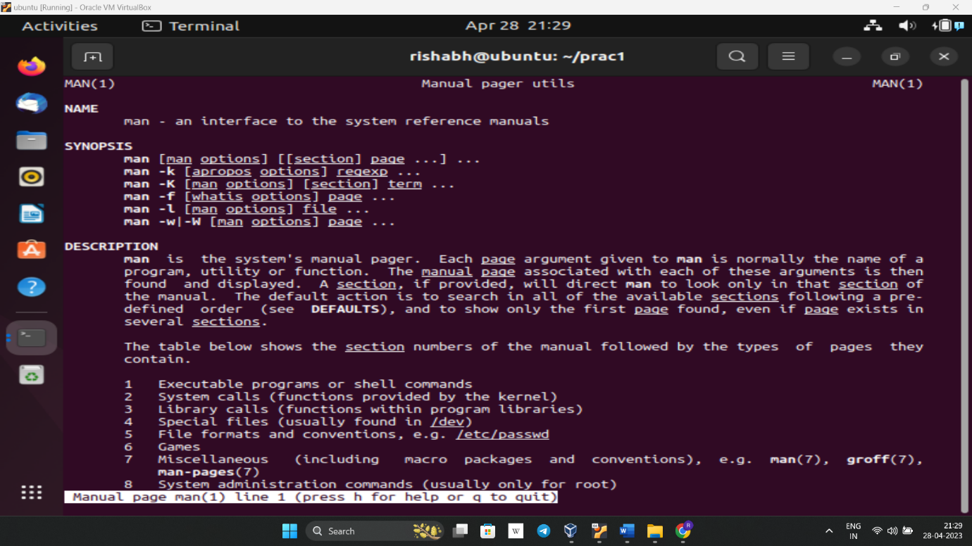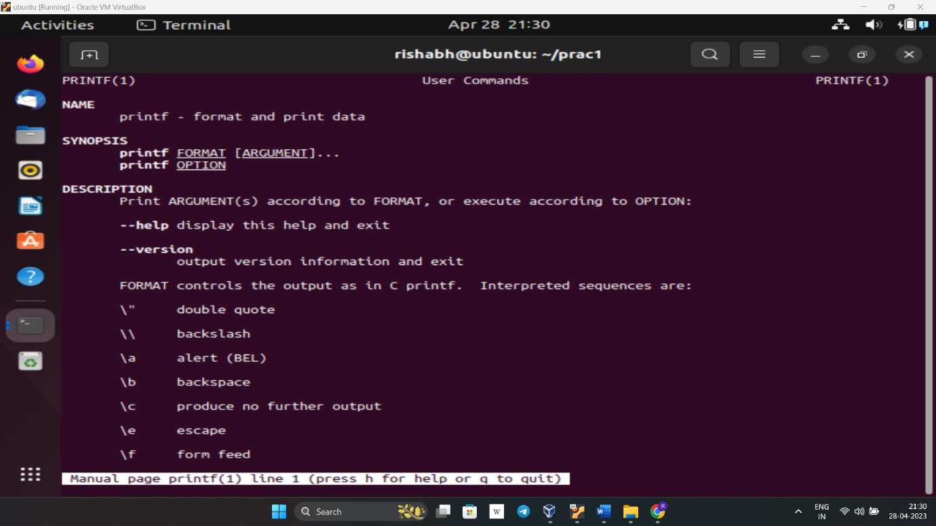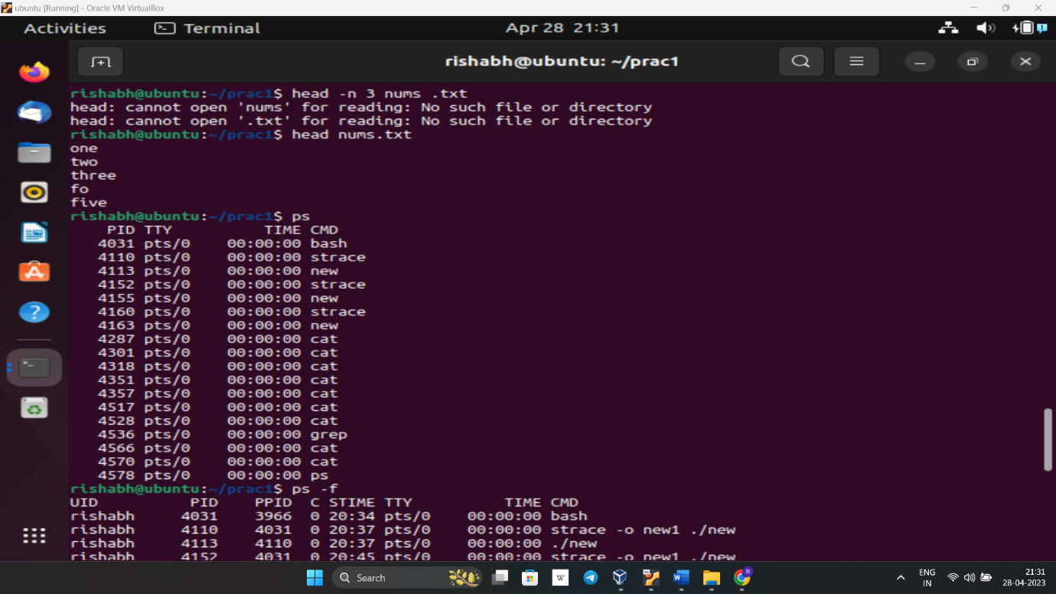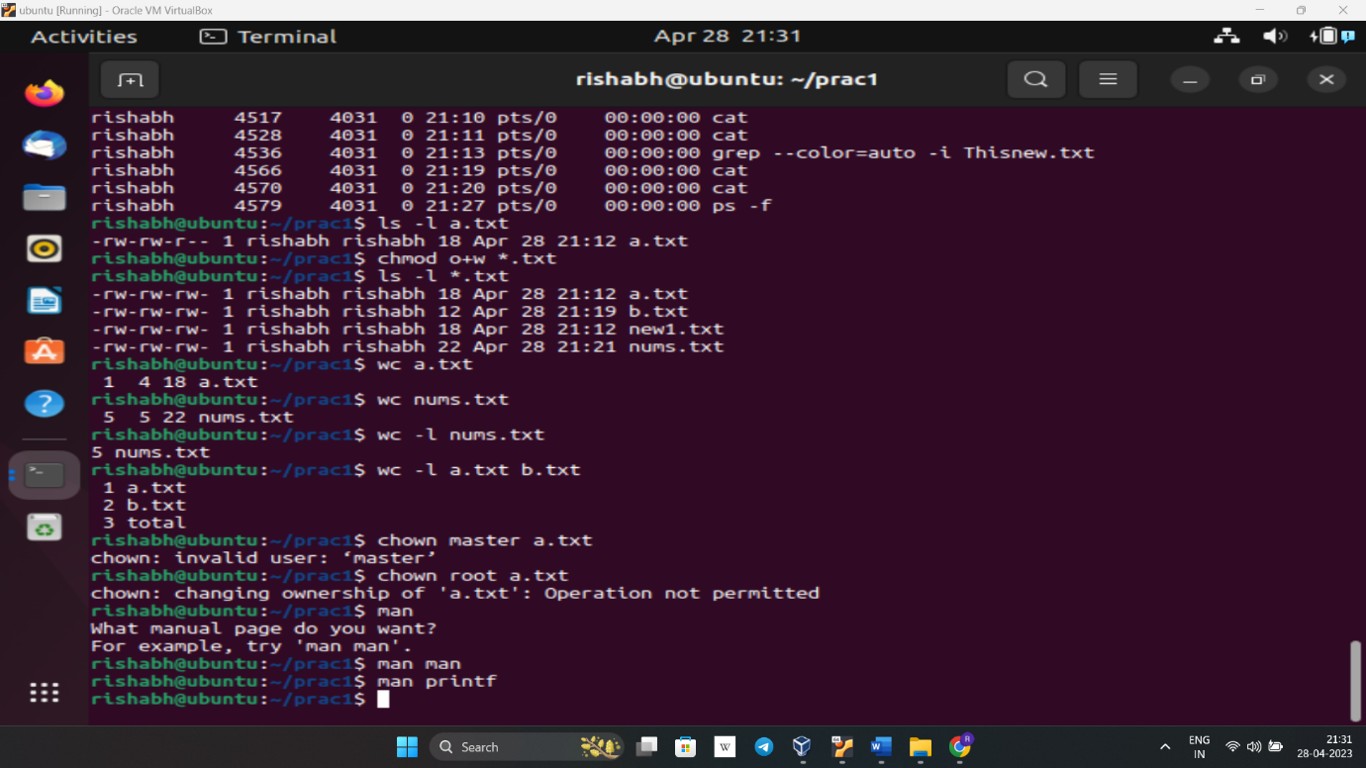

**System calls in 3rd Que**

execve - Takes the filename, arguments and environment variables as input. Returns -1 on error. It

starts the execution of a program

brk - returns 0 on success, -1 on error. Used to change the data segment size. Sets the end of the

data segment to the address mentioned in the argument.

Access - Arguments are filename and a permission. Returns 0 if the user has that permission on that

file else returns -1

Mmap- Maps files into memory. Returns the pointer to the location where it’s mapped. The various

arguments specify the property of the mapped addresses - protection, flags and the file descriptor for

the file and the offset from where to start

Munmap - deletes the mapping for the specified address space. Returns 0 on success, -1 on failure.

Open - Opens/creates a file. Takes input as the file path and flags for read/write etc. and returns the

file descriptor

Read - Input is file descriptor of the file to be read, the buffer to read it in and the number of bytes to

be read. Returns the number of bytes read. Reads from files.

Write - Input is file descriptor of the file to be written, the buffer containing the bytes to write and the

number of bytes to be written. Returns the number of bytes written. Writes to files.

Close - takes file descriptor as input. Closes the file. Returns 0 on success, -1 on failure. Arch_prctl -

Sets architecture specific thread state.

Fstat - takes in a file descriptor and buffer as input. Gets the status of the file(info about the file) and

puts it in the buffer.

Lseek - repositions the file offset of a file. Takes in the file descriptor, and offset and a directive which

tells it what to do with the offset. Returns the final offset after the seek.

Exit_group - exits all threads in the calling process’s thread group

Mprotect - Sets the protection for a given region of the memory. Takes the starting address, size of

the memory region and the protection to set as input.

**Result:** Basic Linux System Commands and shell scripts to display the system particulars (processor, processes and memory) has been implemented.